Self Driving Cars

Neural Network

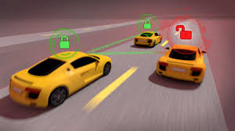

Presented By

Benjamin Hinchman

Jesse Gibbons

Kyle Tolliver

Richard Kung

Shane Mecham

# Analysis Overview

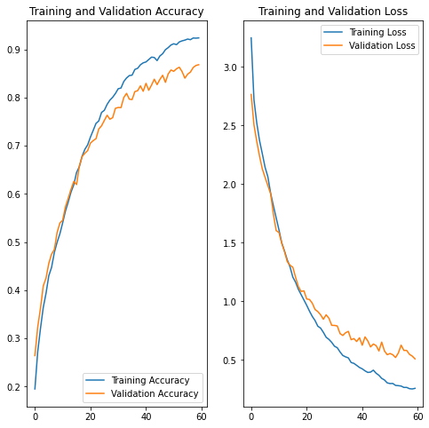

In general using the inception v3, made the training process fairly straightforward. We just needed to add a dense layer and an output layer. With these minor modifications we were able to get an accuracy of 90%, and if some hurdles hadn't presented themselves during the training phase of the model we would have continued working on the accuracy to get it higher. A 90% success rate doesn't seem very good when you consider that 10% of the time a one ton car is misidentifying road signs.

# Conclusions and Caveats

We were able to train our neural networks to improve the accuracy. We also were able to run our algorithm on a CPU, TPU and GPU. We found the speed differences and performance differences on the different processing units.

https://colab.research.google.com/drive/1qqZMo0lBwkZ-1bFcb5B1FjVP80y0DZ-H?usp=sharing